Task 1: Data Modeling & Cleaning

● Load and transform datasets in Power Query
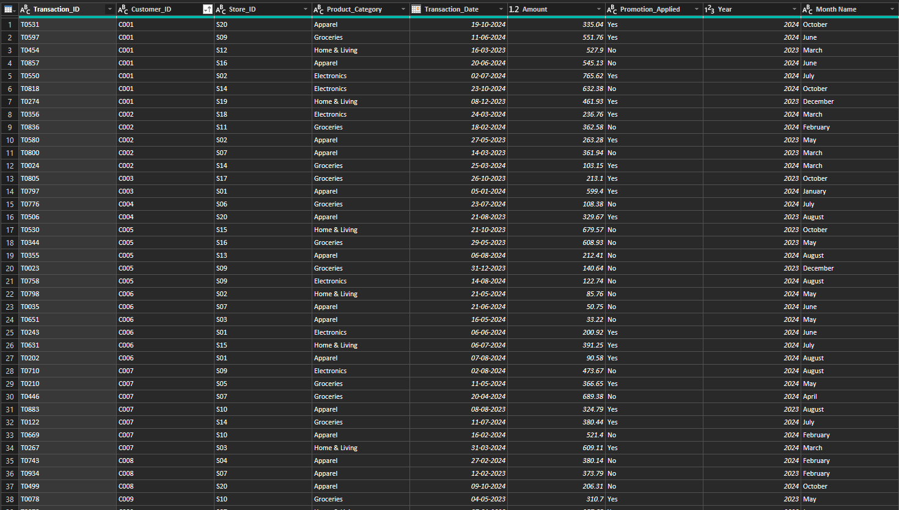

● Handle duplicates, missing values, and ensure correct data types
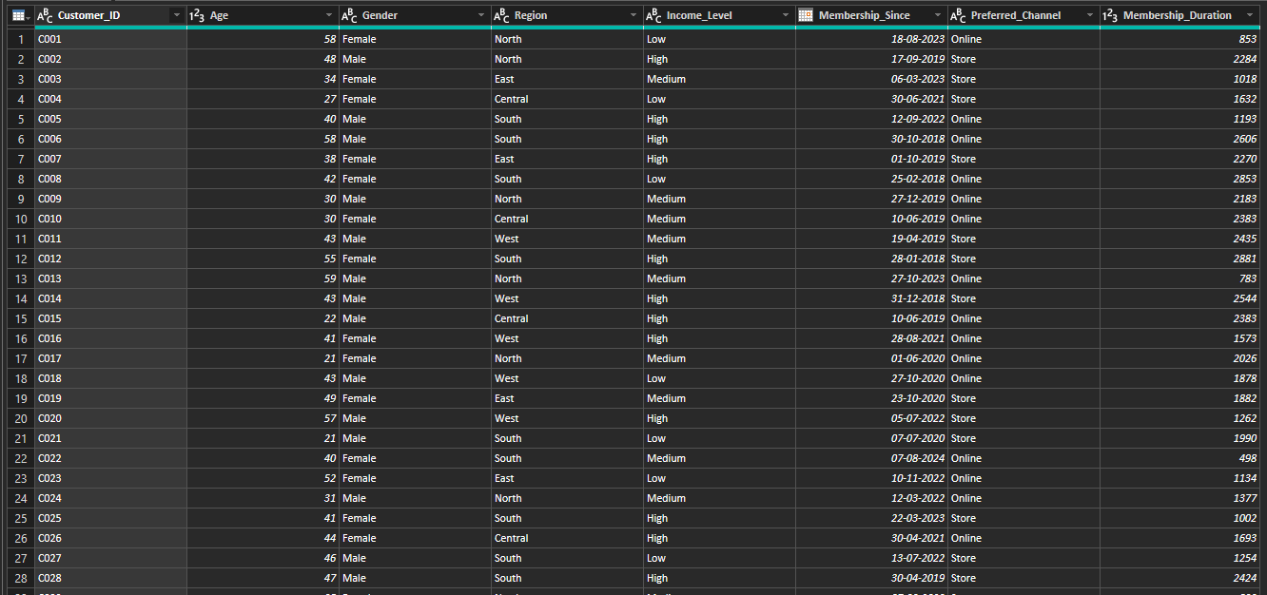

● Create calculated columns:
○ Membership_Duration = Today – Membership_Since
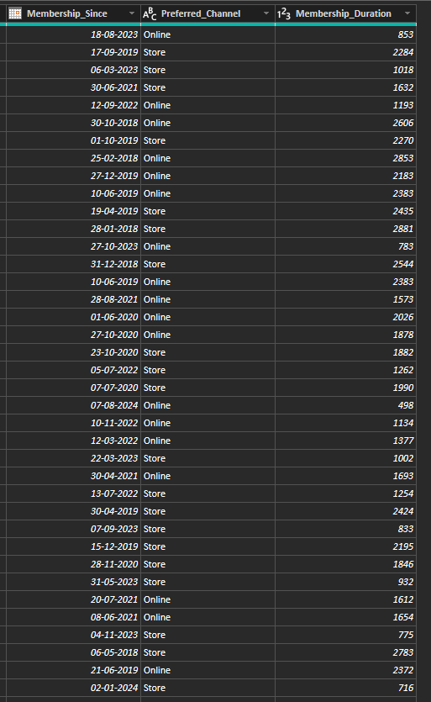
○ Extract Transaction_Year, Transaction_Month
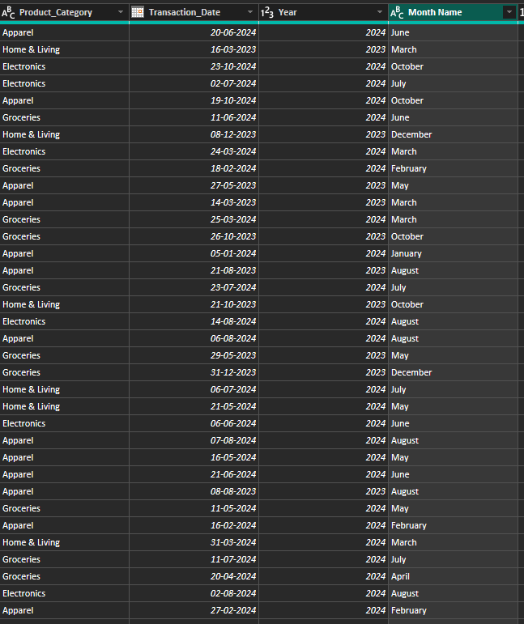

● Create a basic Data Model view
○ One-to-Many: Customer_Demographics → Transactions, Loyalty_Program, Churn_Labelled_Customers
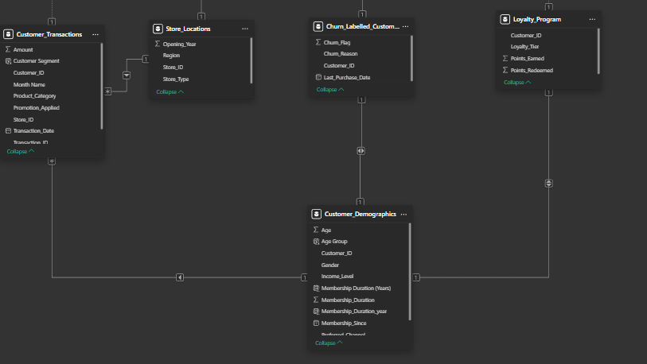
○ Many-to-One: Transactions → Store_Locations
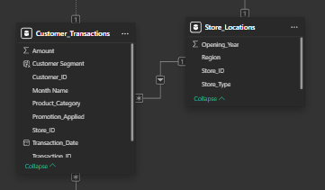

Task 2: Churn & Retention Metrics

● Create Churn Rate KPI = (Churned Customers / Total Customers) * 100
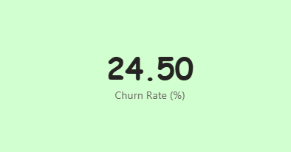
Churn Rate (%) =
DIVIDE(
[Churned Customers],
[Total Customers],
0
) * 100

● Visualize churn rate by:
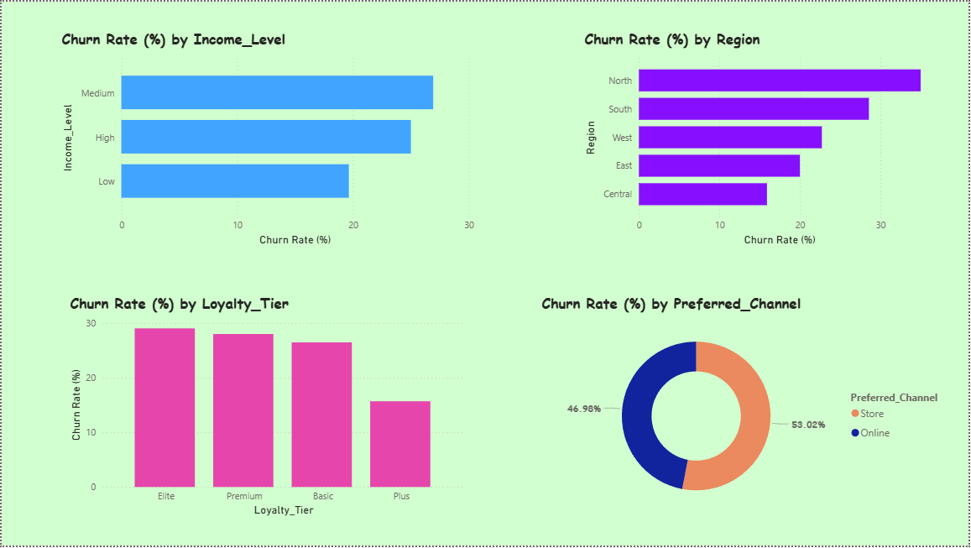

● Funnel Chart: Total Customers → Repeat Customers → Churned
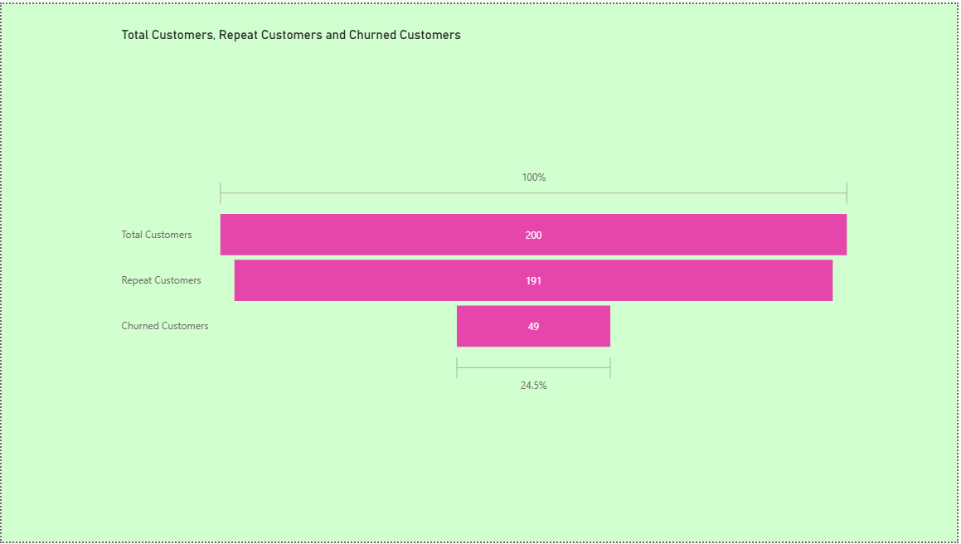

Task 3: Repeat Purchase Analysis

● Segment customers:
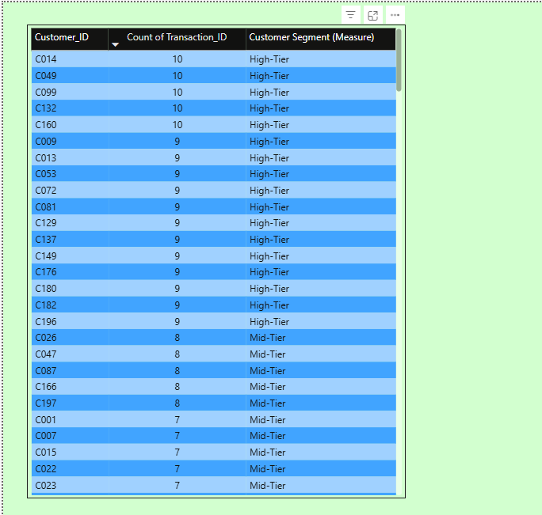
Customer Segment (Measure) =
VAR PurchaseCount =
COUNT(Customer_Transactions[Transaction_ID])
RETURN
SWITCH(
TRUE(),
PurchaseCount <= 3, "Low-Tier",
PurchaseCount <= 8, "Mid-Tier",
"High-Tier"
)

● Compare avg. purchase frequency by Region, Age Group, Loyalty Tier
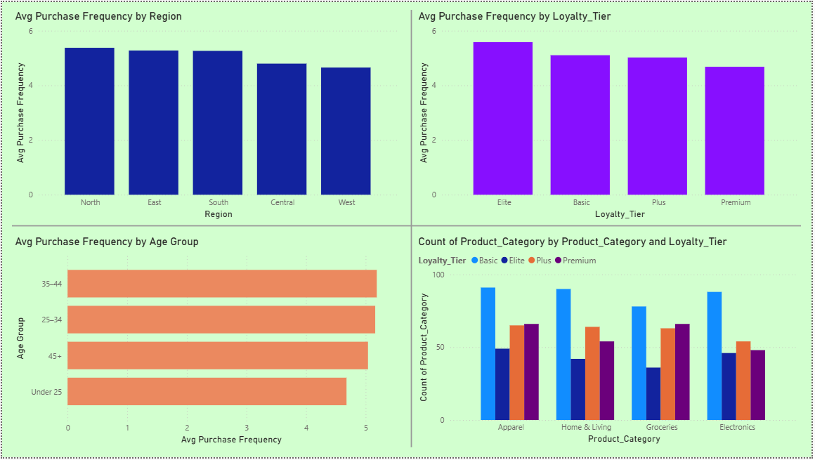

● Identify most purchased product categories by loyal customers
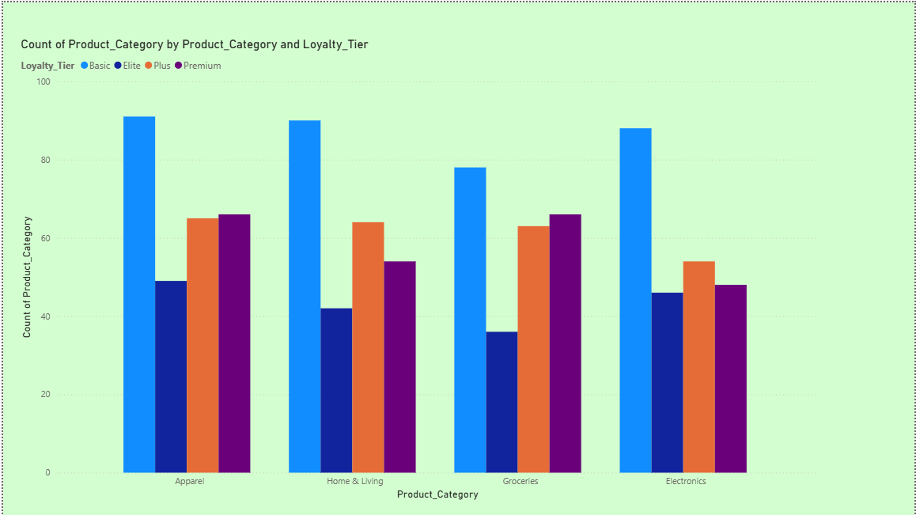

Task 4: Promotion & Loyalty Impact

● Calculate % of transactions with promotion applied.
● Compare average purchase amount with vs. without promotions.
● Analyze churn rate across loyalty tiers.
● Visualize Points Earned vs. Redeemed by Tier (Clustered Column Chart).
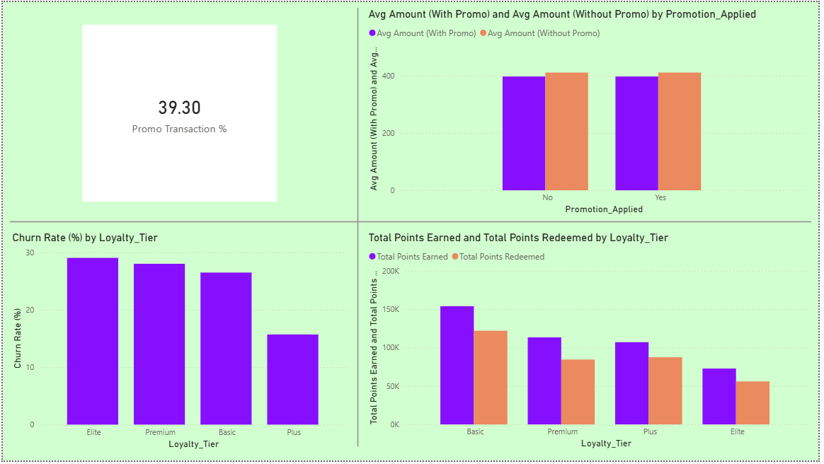
Promo Transaction % =
DIVIDE(
[Promo Transactions],
[Total Transactions],
0
) * 100

Churn Rate (%) =
DIVIDE(
[Churned Customers],
[Total Customers],
0
) * 100

Avg Amount (Without Promo) =
CALCULATE(
[Avg Purchase Amount],
Customer_Transactions[Promotion_Applied] = "No"
)

Avg Amount (With Promo) =
CALCULATE(
[Avg Purchase Amount],
Customer_Transactions[Promotion_Applied] = "Yes"
)

Total Points Earned =
SUM(Loyalty_Program[Points_Earned])

Total Points Redeemed =
SUM(Loyalty_Program[Points_Redeemed])

● Give recommendations to improve redemption & retention.
- Simplify points redemption by lowering minimum limits, allowing partial redemption, and auto-applying points to reduce customer friction.
- Increase loyalty value through tier-exclusive rewards, early sale access, and experiential benefits.
- Improve point usage with expiry reminders and personalized nudges.
- Reduce churn using segment-based retention strategies and personalized offers driven by customer data.
- Optimize promotions by focusing on high-retention categories and testing non-discount incentives.
- Strengthen the loyalty program by fast-tracking tier upgrades, rewarding milestones, and gamifying progress to encourage repeat purchases.

Task 5: Store & Channel Performance vs Retention

● Merge store data with transactions
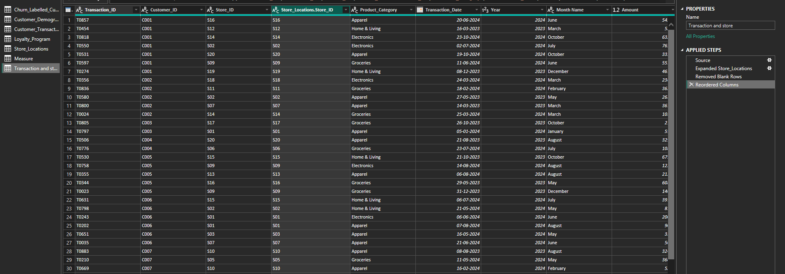

● Visualize:
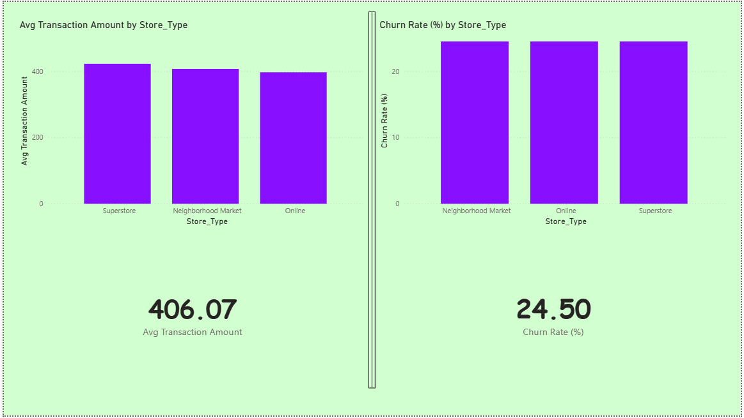

Avg Transaction Amount =
AVERAGE(Customer_Transactions[Amount])

Churn Rate (%) =
DIVIDE(
[Churned Customers],
[Total Customers],
0
) * 100

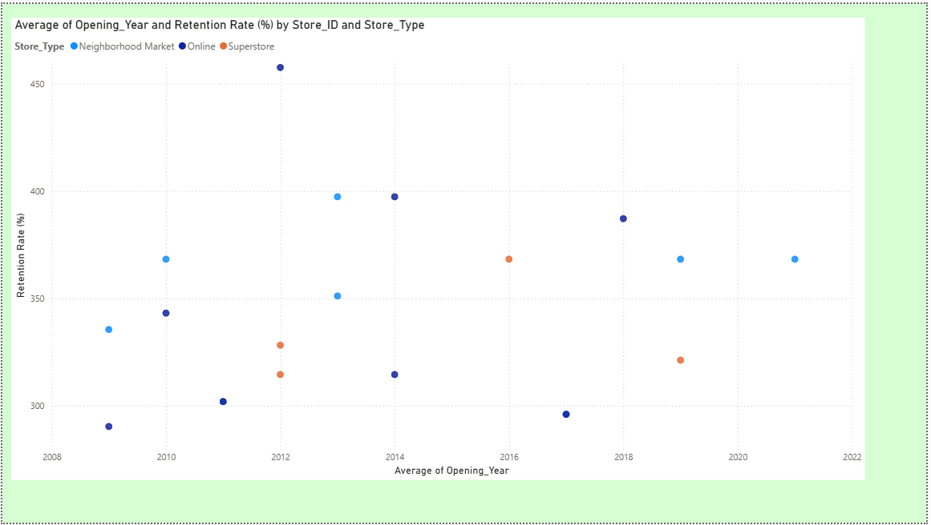
Retention Rate (%) =
DIVIDE(
[Retained Customers],
[Total Customers (Store)],
0
) * 100

Task 6: Customer Lifetime Value

● CLV = Total Amount Spent / Membership Duration (Years)
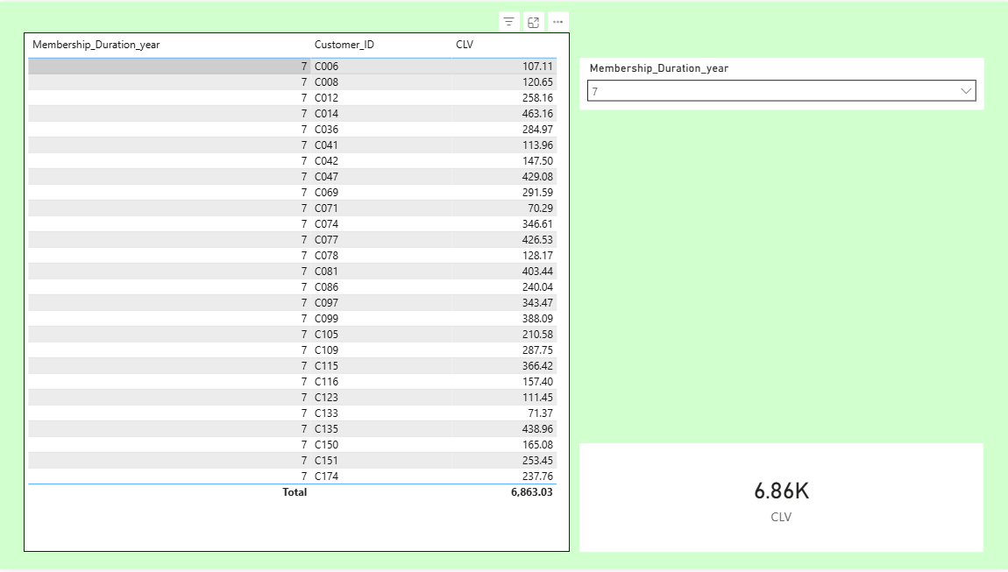
CLV =
DIVIDE(
[Total Amount Spent],
[Membership Duration (Years)],
0
)

● Segment customers into Low, High CLV
○ Above Average CLV as High
○ Below Average CLV value- Low
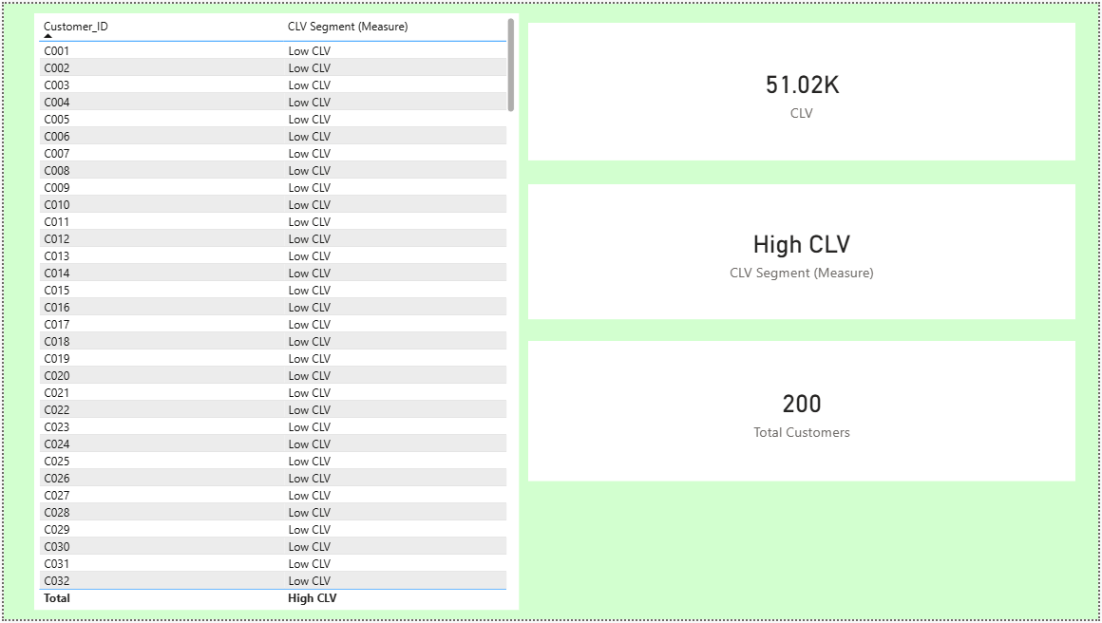

● Visualize:
○ CLV vs Days Since Last Purchase
○ CLV by Loyalty Tier & Region
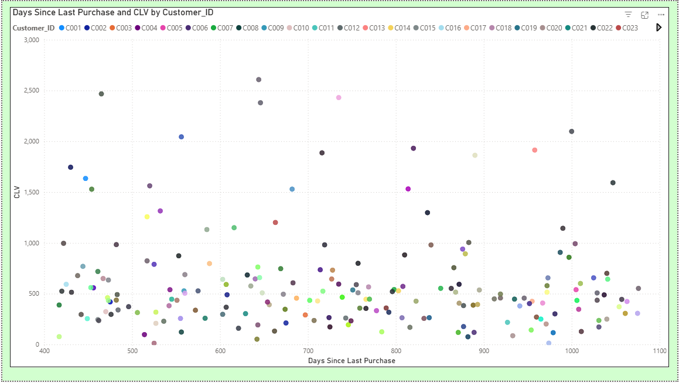
Days Since Last Purchase =
DATEDIFF(
MAX(Churn_Labelled_Customers[Last_Purchase_Date]),
TODAY(),
DAY
)

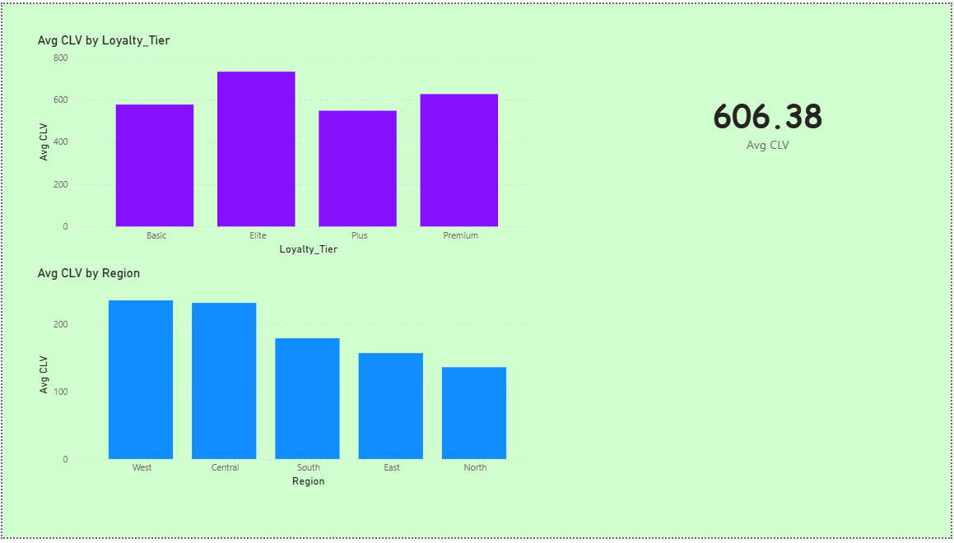

CLV =
DIVIDE(
[Total Amount Spent],
[Membership Duration (Years)],
0
)

Task 7: Final Dashboard & Executive Summary

● Multi-page Power BI Report:
○ Page 1: KPIs (Churn, CLV, Repeat Rate)
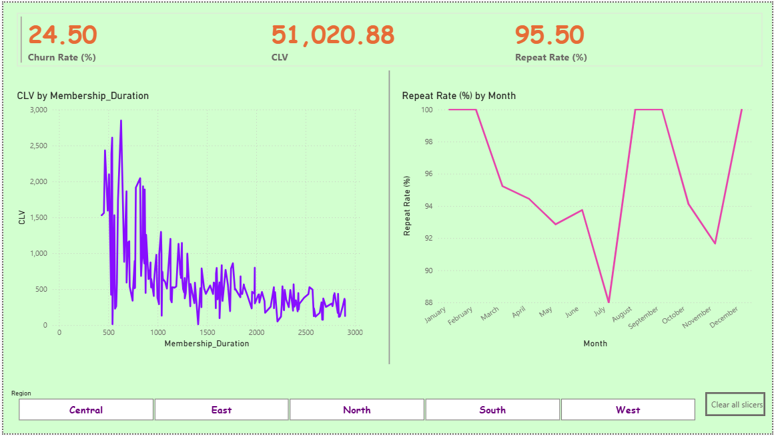

○ Page 2: Loyalty & Promotion Impact

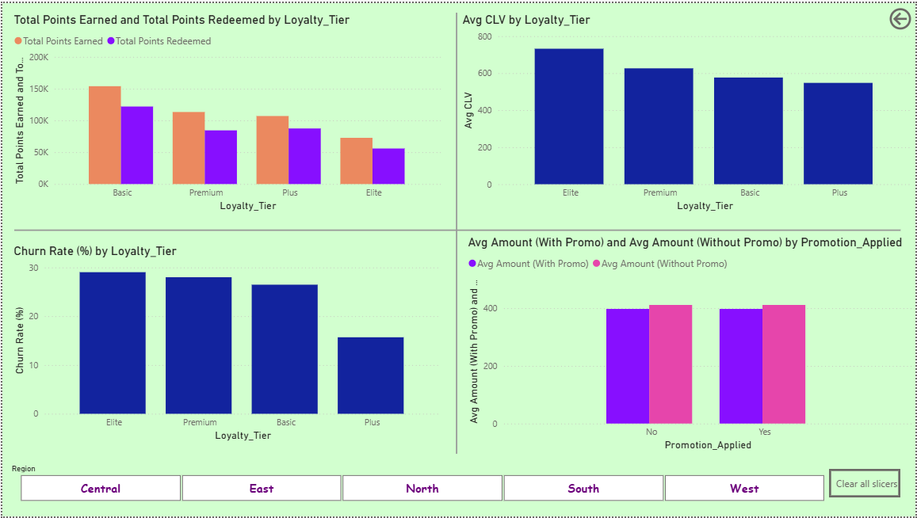

○ Page 3: Store/Channel Insights

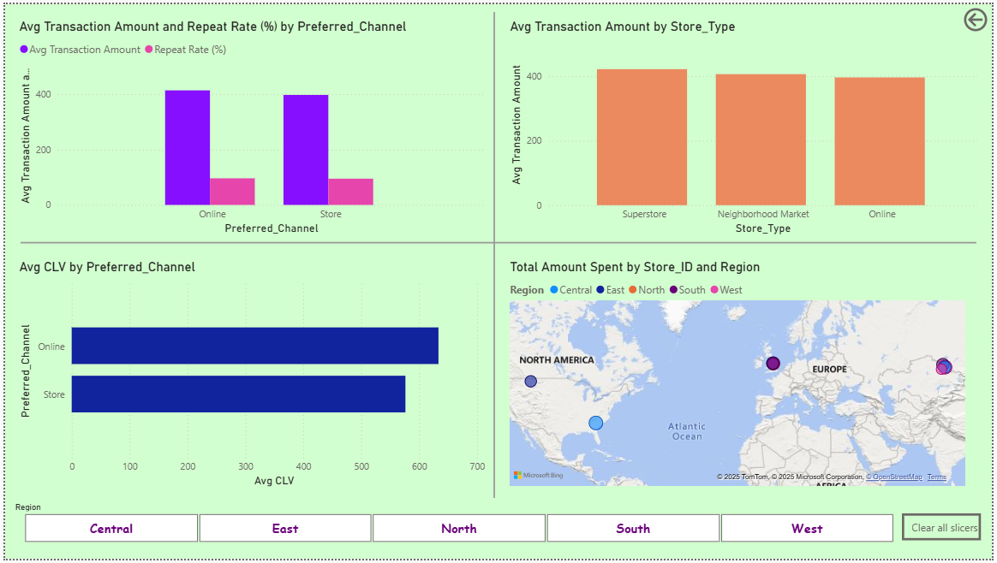

○ Page 4: Segmentation (Churned, Repeat, High-Value)

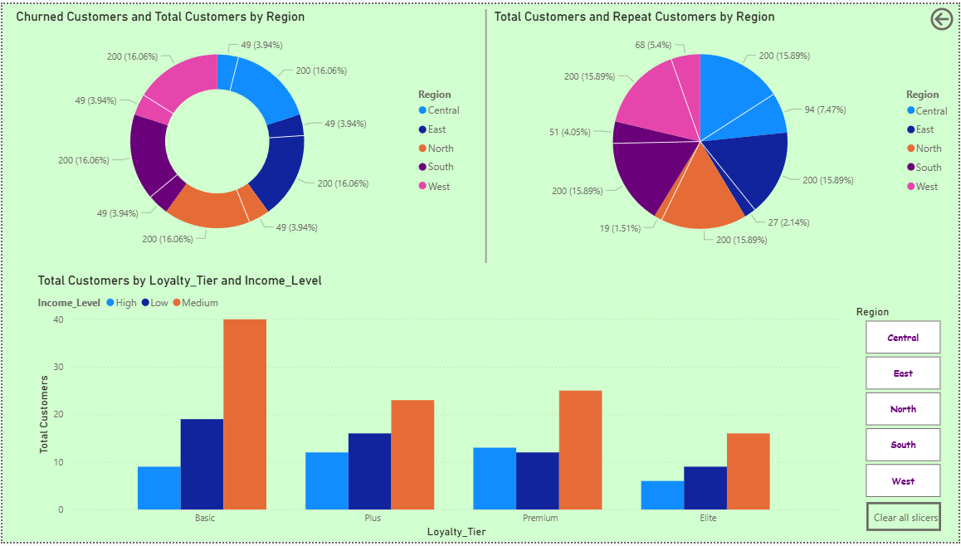

● Slicers: Region, Channel, Income, Loyalty Tier

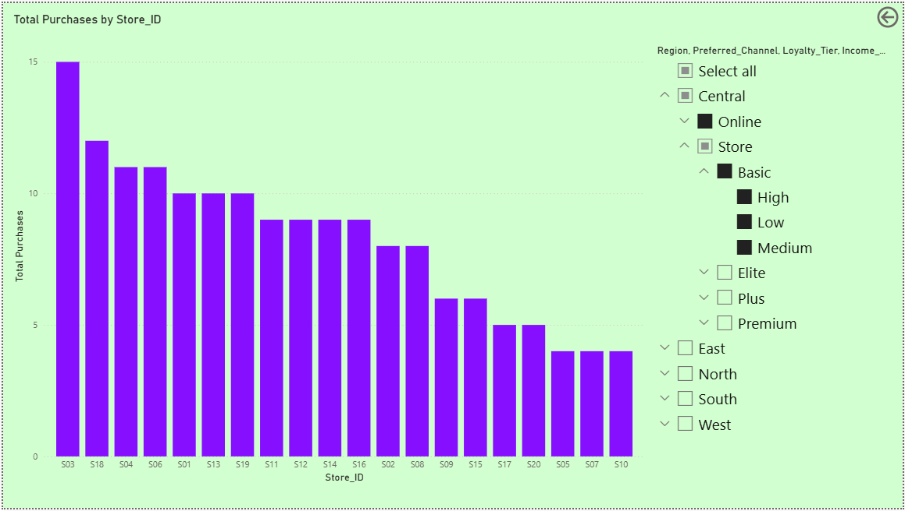

● Provide Top 3 Recommendations for Target:
○ Which customers to prioritize for retention?
- The High or Above-average CLV ,High = “Days Since Last Purchase”
Mostly in Gold / Platinum loyalty tiers ,because they generate the most revenue per year Losing them causes maximum revenue loss

○ Which channels are underperforming?
- Online or Digital Channels are underperforming due to Higher churn rate than offline channels Because of it we get Lower retention rate Customers are often one-time or promo-driven which tends to Lower loyalty engagement and CLV
○ How to strengthen loyalty engagement?
- Make loyalty easy to use by lowering redemption limits, allowing partial redemption, and auto-applying points at checkout. Increase perceived value with tier-based exclusive benefits like early access, free delivery, and priority support. Gamify the program using progress bars, milestones, and purchase streak rewards. Use personalized offers and reminders based on customer behavior and inactivity. Ensure loyalty works consistently across all channels (online & in-store). Track key metrics like redemption rate, repeat purchase rate, churn by tier, and CLV uplift.

